### Practical File

### Of

### Operating System

### 22CS005

#### Submitted

#### in partial fulfillment for the award of the degree of

## BACHELEOR OF ENGINEERING

***in***

COMPUTER SCIENCE & ENGINEERING



**CHITKARA UNIVERSITY**

**CHANDIGARH-PATIALA NATIONAL HIGHWAY**

**RAJPURA (PATIALA) PUNJAB-140401 (INDIA)**

##### June, 2024

##### **Submitted To: Submitted By:**

##### Dr. Meenakshi Malhotra Jay Soni

##### Associate Professor 2310991943

##### Chitkara University, Punjab G-22,Sem-2

**INDEX**

|  |  |  |
| --- | --- | --- |
| **Sr. No.** | **Practical Name** | **Teacher Sign** |
| 1 | 1. Installation: Configuration & Customizations of Linux 2. Introduction to GCC compiler: Basics of GCC, Compilation of program, Execution of program. 3. Time stamping in Linux. 4. Automating the execution using Make file. |  |
| 2 | Implement the basic and user status commands like: su, sudo, man, help, history, who, whoami, id, uname, uptime, free, tty, cal, date, hostname, reboot, clear. |  |
| 3 | Implement the commands that is used for Creating and Manipulating files: cat, cp, mv, rm, ls and its options, touch and their options, which is, where is, what is,the basics of the Unix file system. |  |
| 4 | Implement Directory oriented commands: cd, pwd, mkdir, rmdir, Comparing Files using diff, cmp, comm. |  |
| 5 | Write a program to create and execute process using fork() and exec() system calls. |  |

**Program 1: a)** **Installation: Configuration & Customizations of Linux**

**LINUX:** Linux is an open-source Unix-like operating system-based family on the Linux kernel, and the OS kernel was first published on 17 September 1991 by Linus Torvalds. Typically, Linux is packaged as the Linux distribution, which contains the supporting libraries, system software, and kernel, several of which are offered by the GNU Project. Linux powers servers, desktops, smartphones, and embedded systems, offering various customization options.

**Virtual Box:** VirtualBox is an open-source software for virtualization that allows users to run multiple operating systems on a single machine simultaneously. Essentially, with VirtualBox, you can emulate a particular computer system on your device without affecting your primary OS.

**Installation of Virtual Box:**

To install the virtual box, first go to your web browser and type <https://www.virtualbox.org/wiki/Downloads>.

When you go to this link you will be able to see various platform packages.

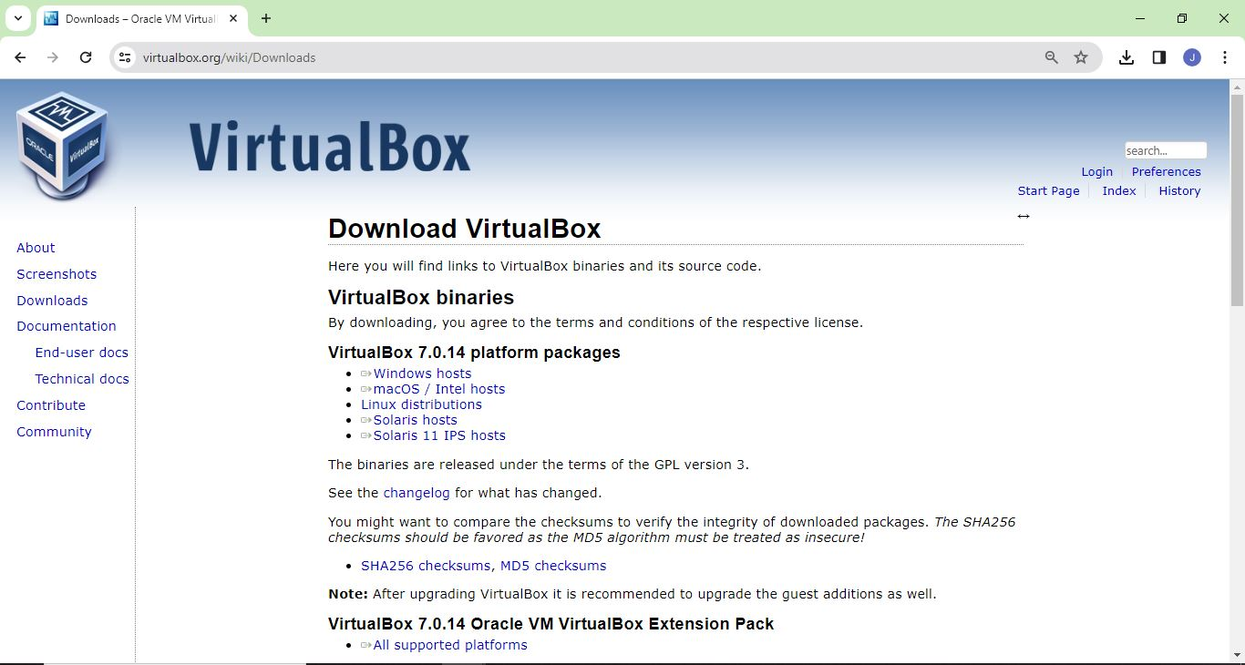

From the various options, we are going to select Windows Hosts and when we click on it our virtual box will start getting installed.

Once the download is complete, open setup file and follow the steps below:

Step 1-Click on next.

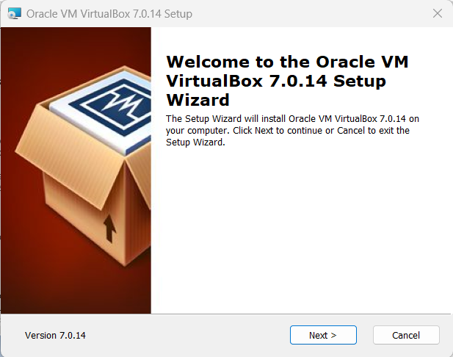

Step 2- Select the location where you want to install the virtual box and click on next.

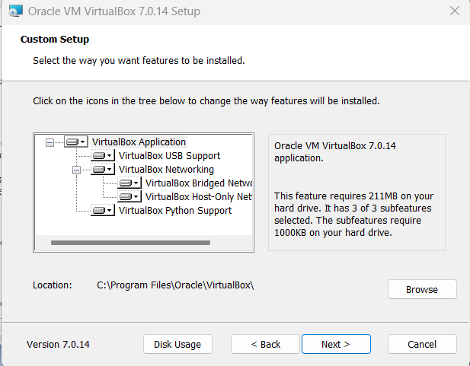

Step 3-Now click on yes.

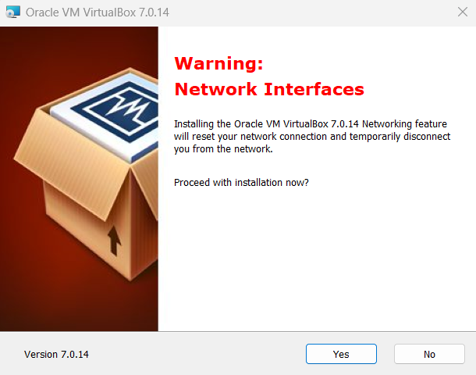

Step 4- Click on Install to install Linux on Windows.

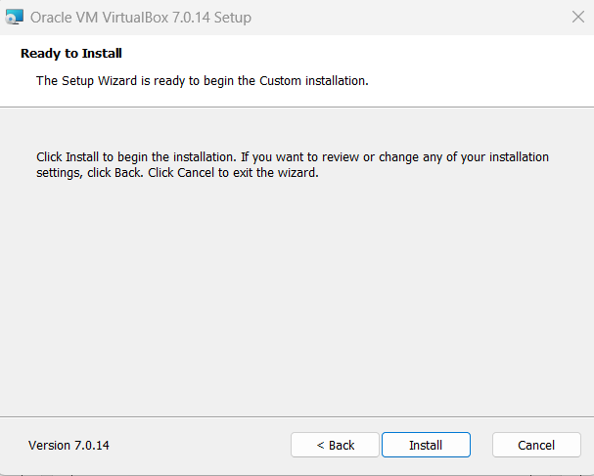

Step 5-Now installation of virtual box will start. Once complete, click on the Finish Button to start Virtual box.

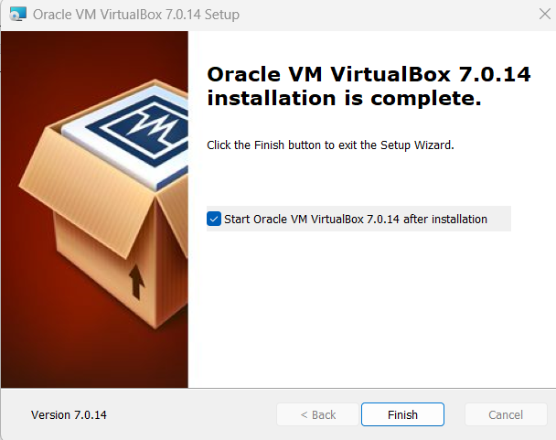

The virtual box dashboard looks like this.

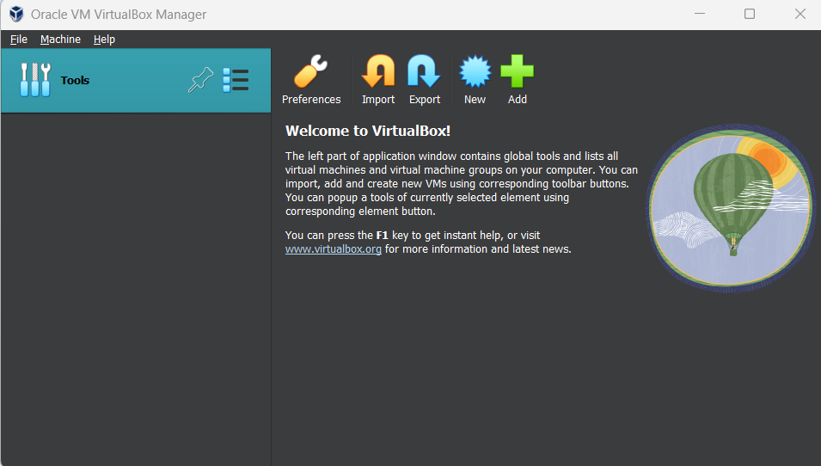

**Download Ubuntu:**

To download Ubuntu visit the link <https://ubuntu.com/download/desktop>

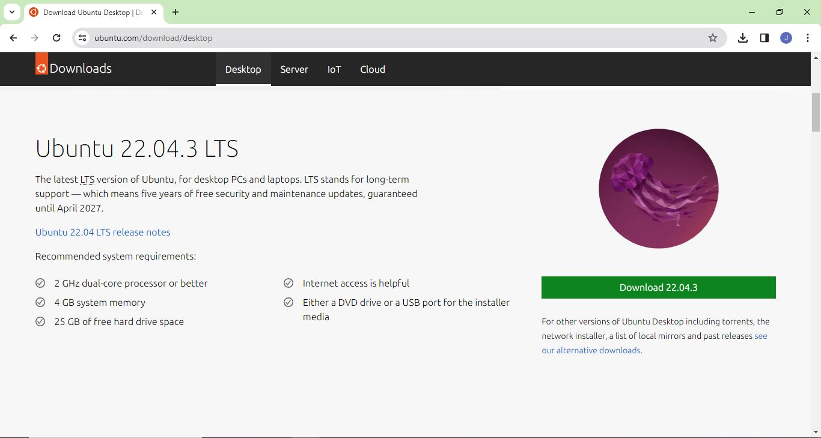

**Create a machine in virtual box:**

Step 1-Open virtual box and click on the new button. A new window will appear and give the name of the OS you are installing and select OS as Linux and version as Ubuntu(64 bit). Click on next.

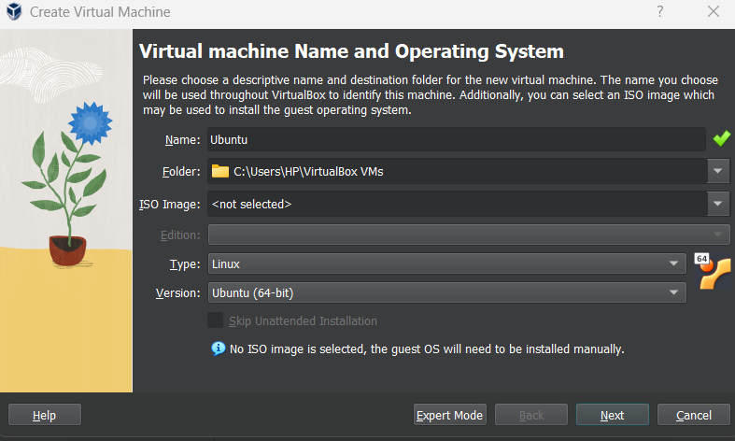

Step 2-Now allocate Base memory and processors to your virtual os.

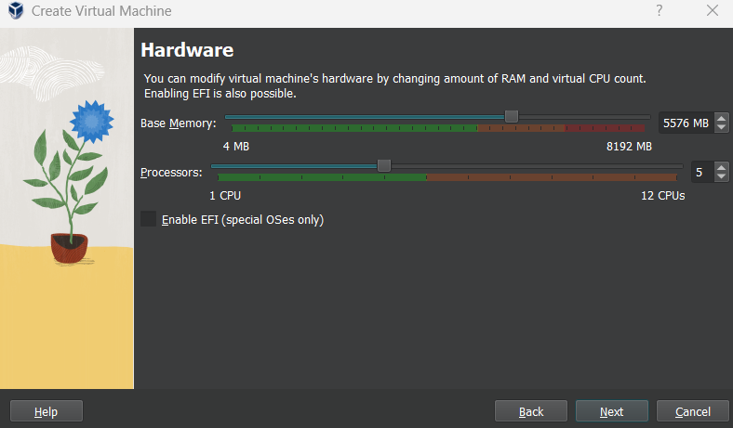

Step 3-Now create virtual hard disk of any size you want.

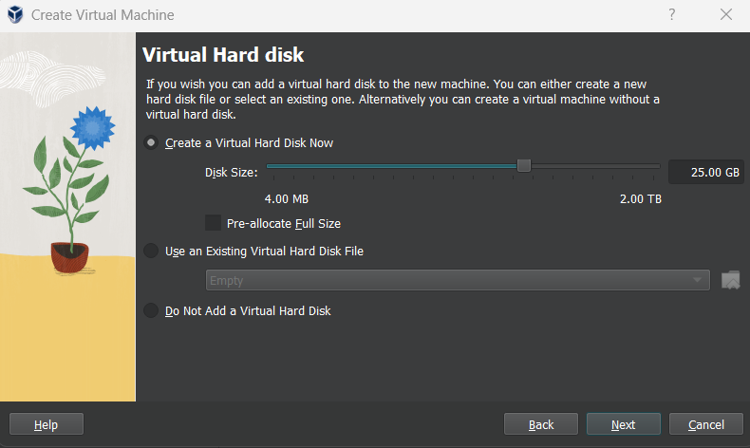

Step 4-Now click on finish.

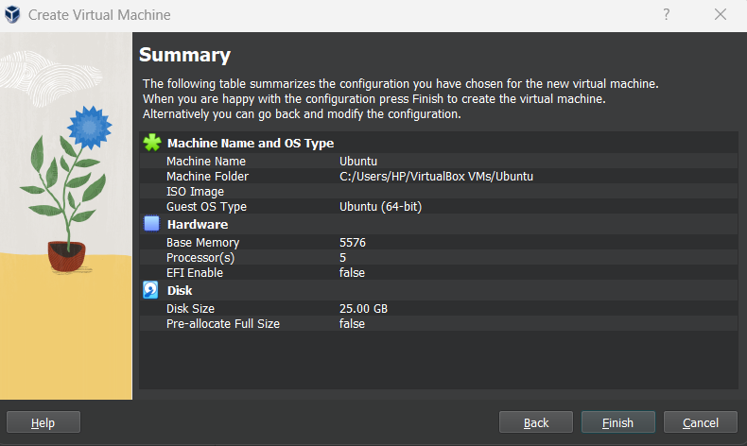

Step 5-Now you can see the machine name in left panel.

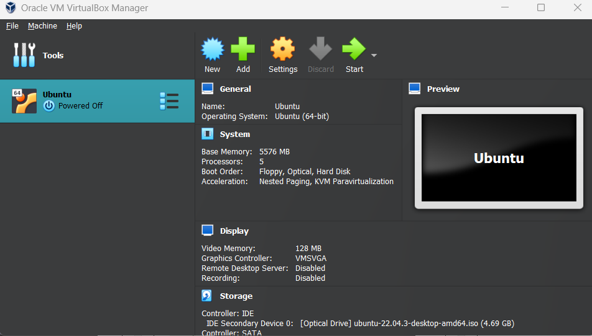

**How to install Ubuntu**

Step 1-Go to settings and then click on storage and add the .iso file of the ubuntu.

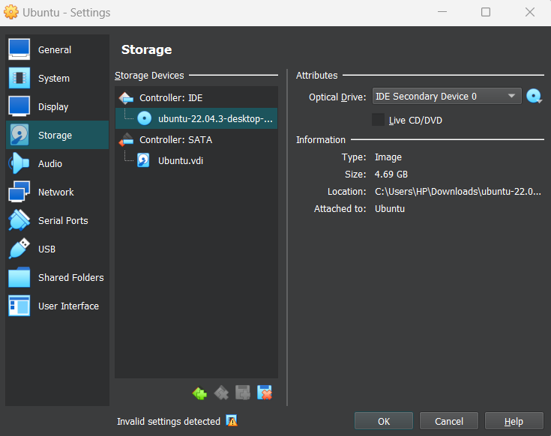

Step 2-Click on Start and select try and install Ubuntu.

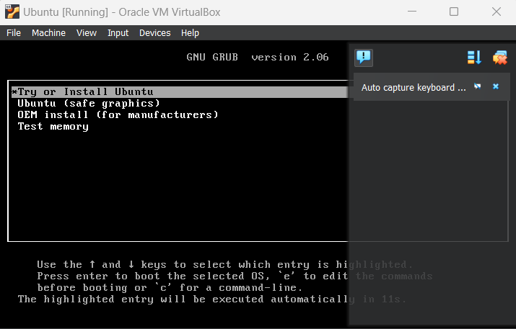

Step 3-Now click on install ubuntu.

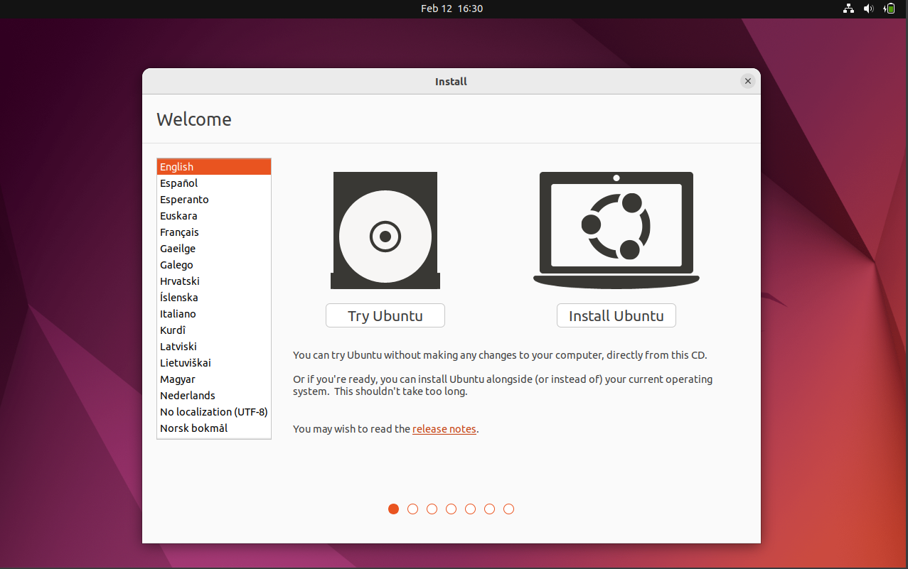

Step 4-Now click on continue

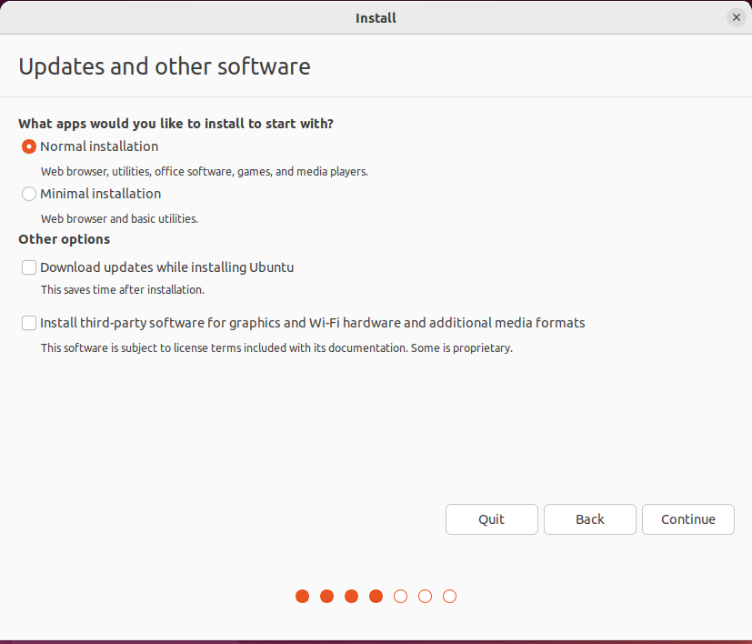

Step 5-Select option to erase the disk and install ubuntu and click on install now.This option installs ubuntu into your virtual hard drive which is we made earlier.It will not harm your pc on windows installation.

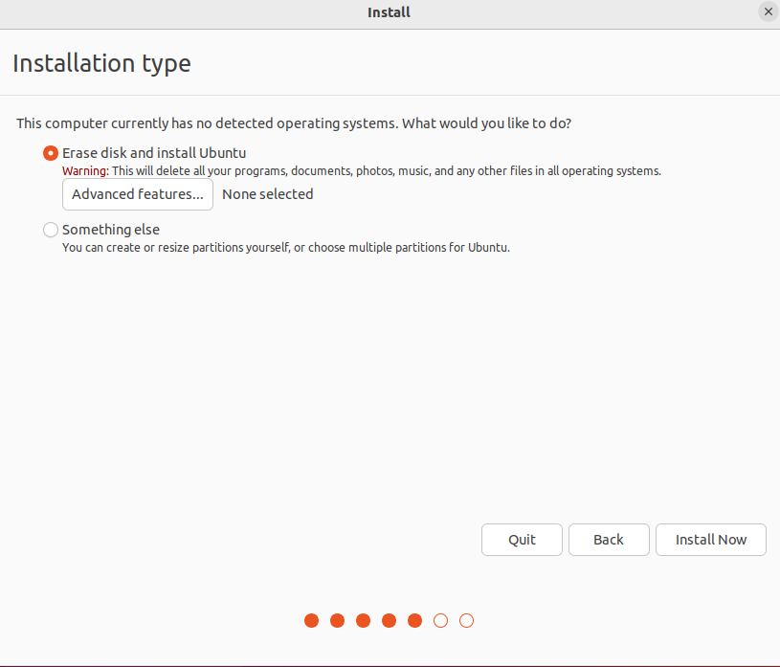

Step-6-Select your username and password for your Ubuntu admin account.

Step-7-Now the installation process starts.

After finishing the installation, you will see the Ubuntu desktop.

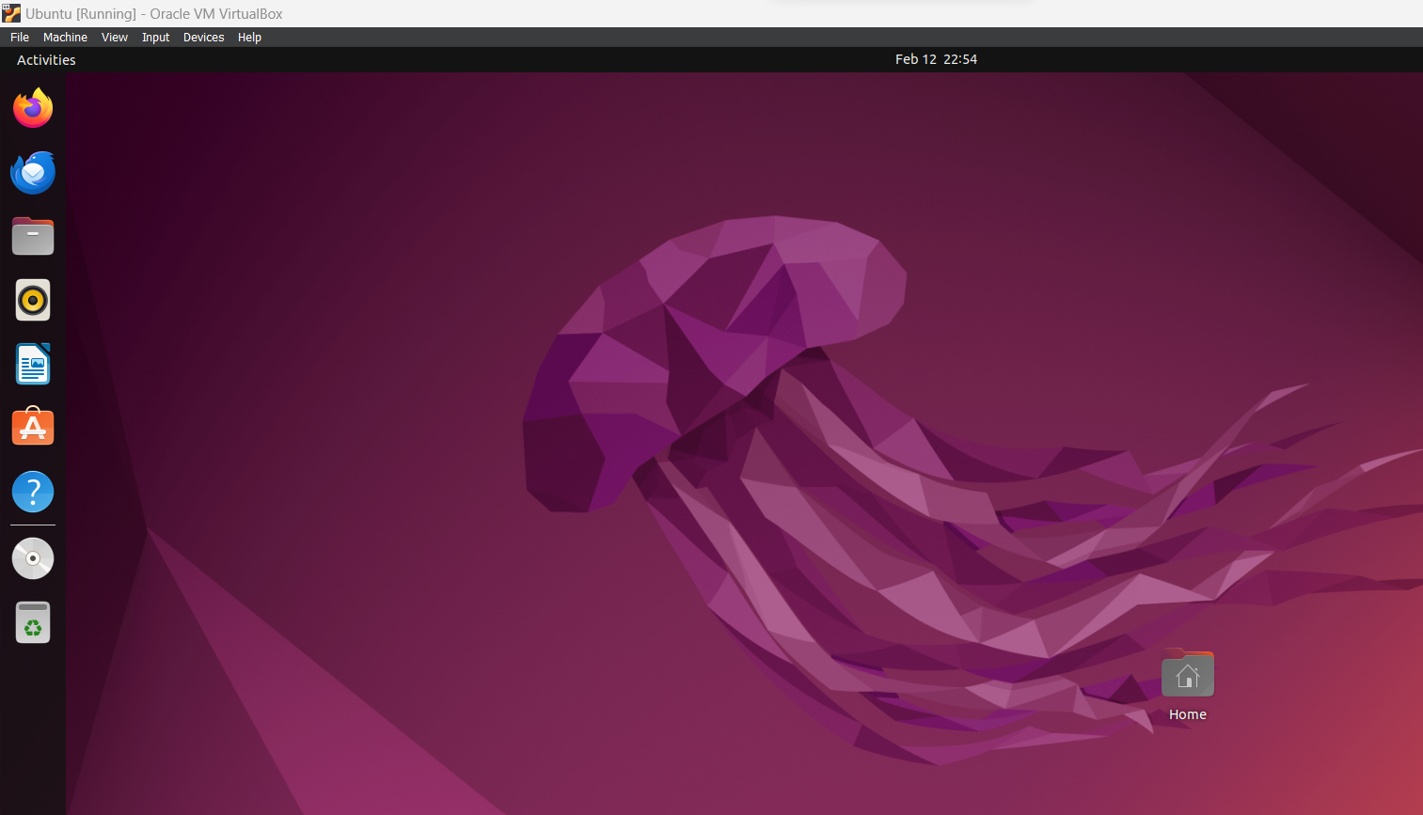

**Program 1(b): Introduction to GCC compiler: Basics of GCC, Compilation of program, Execution of program.**

**GCC compiler:**

In Linux, the GCC stands for GNU Compiler Collection. It is a compiler system for the various programming languages. It is mainly used to compile the C and C++ programs. It takes the name of the source program as a necessary argument; rest arguments are optional such as debugging, warning, object file, and linking libraries.

**Installation of GCC:**

By default, it comes with the most Linux distributions. We can verify it by executing the below command:

$gcc -version

The above command will display the installed version of the GCC tool.

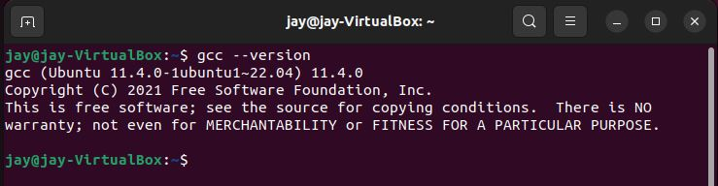

If it is not installed, follow the below steps to install it:

Step 1: Update the package list.

To update the package list, execute the following command:

$sudo apt update

It will ask for the system administrative password, enter the password. It will start updating the system package. Consider the snap of output on next page.

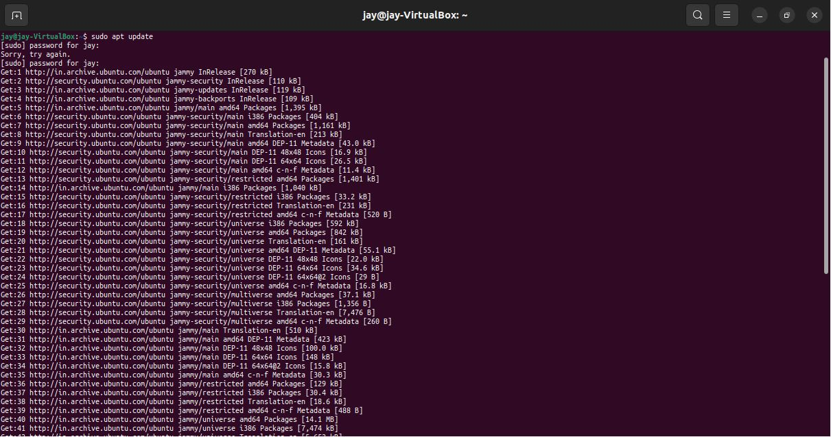

Step 2: Install the build-essential package.

It contains various packages such as gcc, g++, and make utility.

Execute the below command to install it:

$sudo apt install build-essential

The above command will install the required packages for the GCC utility. Now, we can use the GCC utility in our machine.

Consider the snap of output on next page:

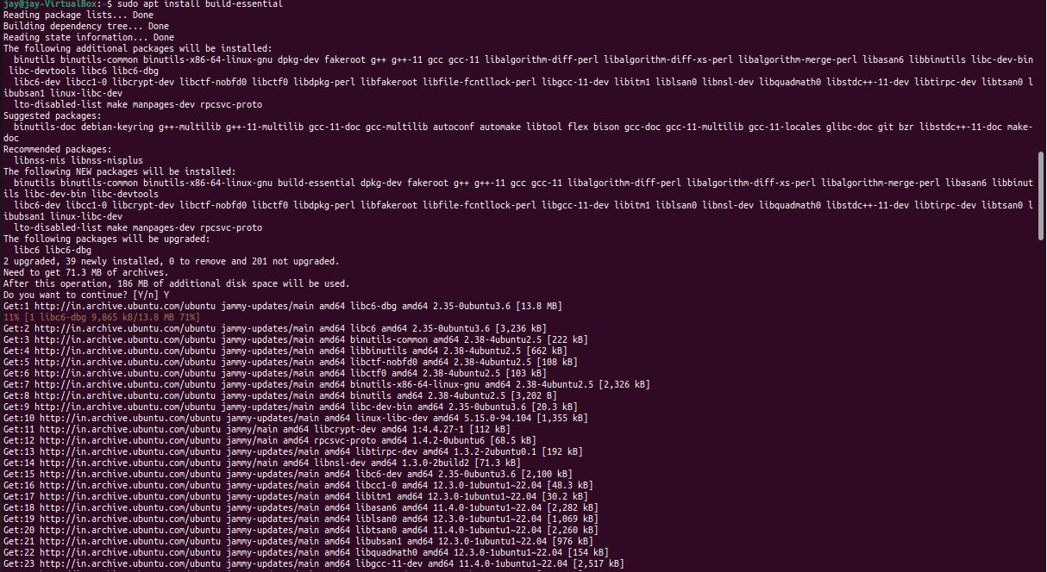

Step 3: Verify the installation.

To verify the installation, execute the gcc -version command as follows:

$gcc --version

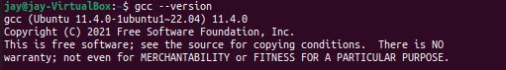

It will display the installed version of GCC utility. To display the more specific details about the version, use the '-v' option.

Consider the output on next page:

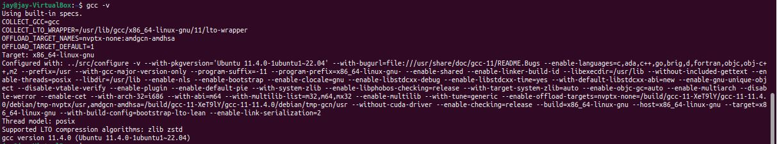

Here, we have successfully installed the GCC utility. Let's understand how to use it. We will create and execute some c programs using GCC. Run the first C program by gcc Create a basic c program "Hello World".

Create a file 'file.c" and put the below code in it:

#include<stdio.h>

#include<unistd.h>

int main() {

printf("Hello World");

return 0;

}

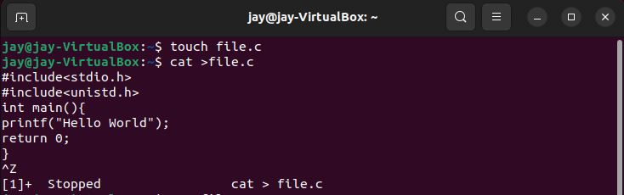

Now, compile the file.c

1. gcc file.c

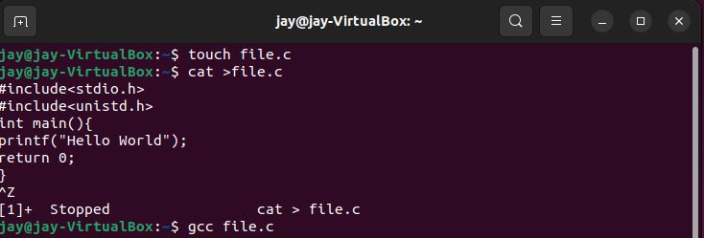

2) ./a.out

Consider the below output

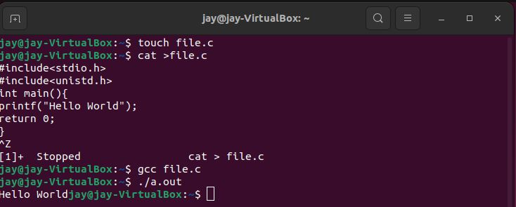

**Program 2: Implement the basic and user status commands like: su, sudo, man, help, history, who, whoami, id, uname, uptime, free, tty, cal, date, hostname, reboot, clear.**

**Introduction:**

Linux is famous for its powerful commands. To use Linux effectively, all users should know how to use terminal commands. Although the OS has a GUI, many functionalities work faster when run as commands through the terminal.

**Prerequisites:**

1. A system running Linux.

2. Access to the command line/terminal.

**Basic Linux Commands:**

1. **sudo command-** It allows you to run programs with the security privileges of another user(by default, as the superuser).

Syntax: sudo

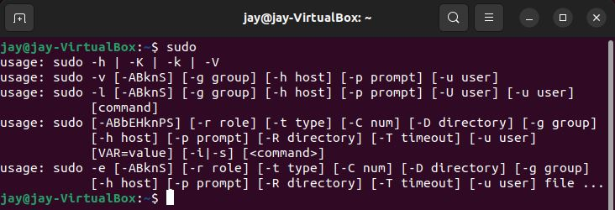

1. **man command-** It is used to display the user manual of any command that we can run on the terminal.

Syntax: man [command]

Example: man ls

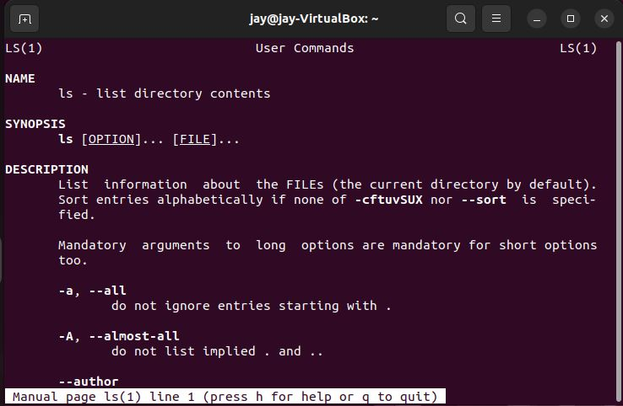

1. **history command-** This feature allows users to recall, reuse, and modify commands without having to retype them.

Syntax: history

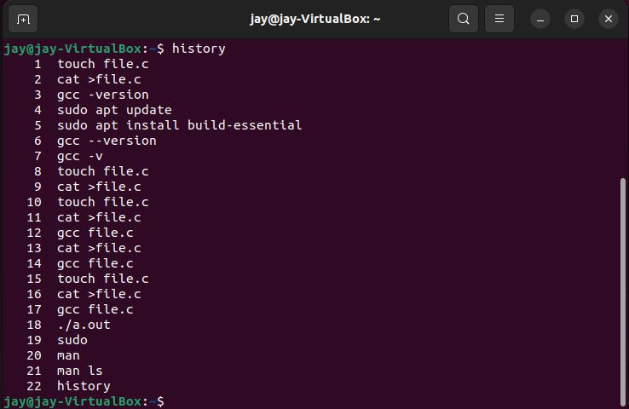

1. **who command-** It is a tool that prints information about users who are currently logged in. who command only sees a real user who logged in.

Syntax: who

C:\Users\Dell\Desktop\OS\13.JPG

1. **whoami command-** The command **whoami** in **Linux** is the concatenation of the words **“Who am I?”** It displays the username of the effective user associated with the current shell session.

Syntax: whoami

C:\Users\Dell\Desktop\OS\14.JPG

1. **id command-** The id command in Linux is used for displaying the real and effective user ID and group ID of a user.

Syntax: id

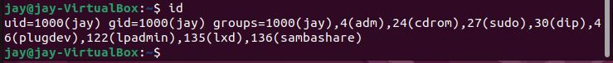

1. **uname command**- The **uname** command writes to standard output the name of the operating system that you are using.

Syntax: uname

C:\Users\Dell\Desktop\OS\16.JPG

There are additional options which provide flexibility with the display output.

* **uname -m-** Displays the machine ID number of the hardware running the system.

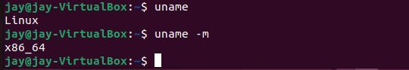

* **uname -r-** Displays the release number of the operating system.

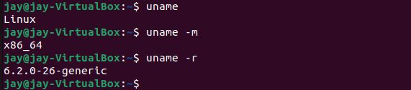

1. **uptime command-** It is used to find out how long the system is active (running).

Syntax: uptime

C:\Users\Dell\Desktop\OS\19.JPG

1. **cal command-** It is a calendar command in Linux which is used to see the calendar of a specific month or a whole year.

Syntax: cal [[month] year]

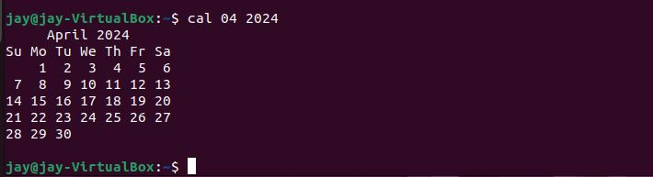

1. **hostname command-** The Linux hostname command allows us to set and view the hostname of the system. A hostname is the name of any computer that is connected to a network that is uniquely identified over a network. It can be accessed without using a particular IP address.

Syntax: hostname

C:\Users\Dell\Desktop\OS\20.JPG

1. **date command-** It is used to display the system date and time.

Syntax: date



1. **clear command-** It is a standard Unix computer operating system command that is used to clear the terminal screen.

Syntax: clear

1. **reboot command-** It is used to restart or reboot the system. In a Linux system administration, there comes a need to restart the server after the completion of some network and other major updates. It can be software or hardware that is being carried on the server. Rebooting is needed so that the changes that the user has made can affect the server.

Syntax: reboot

**Program 3: Implement the commands that is used for Creating and Manipulating files: cat, cp, mv, rm, ls and its options, touch and their options, which is, where is, what is,the basics of the Unix file system.**

**Commands:**

1. **cat command-** The cat command on Linux concatenates files together. It's often used to concatenate one file to nothing to print the single file's contents to the terminal. This is a quick way to preview the contents of a text file without having to open the file in a large application.

Syntax: cat file1

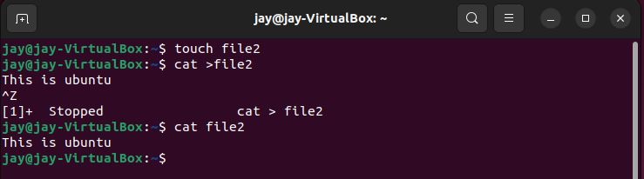

1. **cp command-** The cp command copies the source file specified by the SourceFile parameter to the destination file specified by the TargetFile parameter. If the target file exists, cp overwrites the contents, but the mode, owner, and group associated with it are not changed.

Syntax: cp [file1][file2]

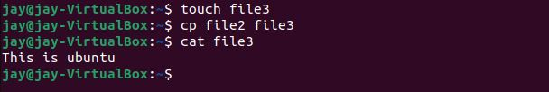

1. **mv command-** The mv command moves files and directories from one directory to another or renames a file or directory. If you move a file or directory to a new directory, it retains the base file name. When you move a file, all links to other files remain intact, except when you move it to a different file system.

Syntax: mv [file1][file2]

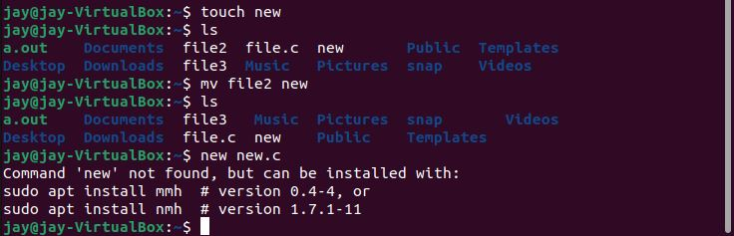

1. **rm command-** It is a general command in Unix and other Unix-like systems. It deletes objects like symbolic links, directories, and computer files from the file systems.

Syntax: rm [file]



1. **ls command-** The ls command is one of the more basic commands in Linux. It is designed to list the names and features of files and directories. It can be used for a single file or as many as all files and folders in a selected set of directories.

Syntax: ls

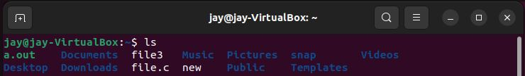

There are additional options which provide flexibility with the display output:

* ls -l: It gives the output as a list.

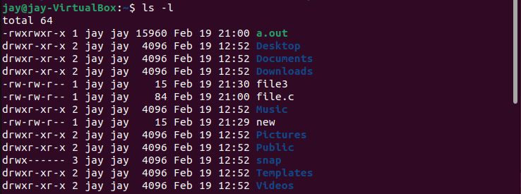

* ls -la: It gives the output as a list but also include some hidden files.

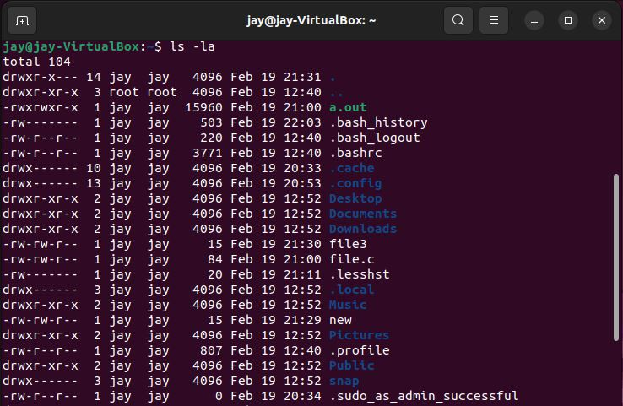

* ls -a: In Linux, hidden files start with. (dot) symbol and they are not visible in the regular directory. The (ls -a) command will enlist the whole list of the current directory including the hidden files.

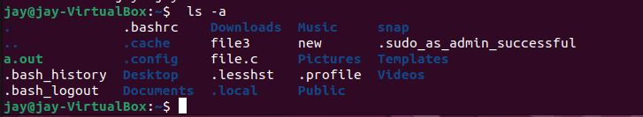

1. **touch command-** The touch command in Linux is used to create a new empty file and to change the timestamps of existing files. You can use it with the syntax: touch file. txt.

Syntax: touch [filename]

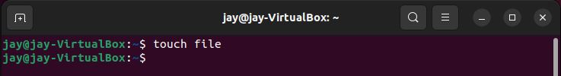

* touch -a: To change file access and modification time.

C:\Users\Dell\Desktop\OS\30.JPG

* touch -m: It is used to only modify time of a file.

C:\Users\Dell\Desktop\OS\31.JPG

* touch -r: To update time of one file with reference to the other file.

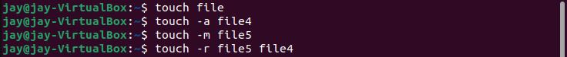

* touch -c: It doesn't create an empty file.

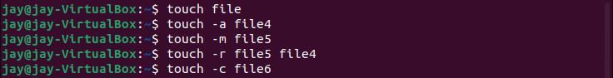

1. **whereis command-** This command is used to find the location of source/binary file of a command and manuals sections for a specified file in Linux system.

Syntax: whereis [command_name]

C:\Users\Dell\Desktop\OS\34.JPG

1. **which command-** which command in Linux is a command that is used to locate the executable file associated with the given command by searching it in the path environment variable.

Syntax: which [command_name]



1. **whatis command-** This command in Linux is used to get a one-line manual page description. In Linux, each manual page has some sort of description within it. So, this command search for the manual pages names and show the manual page description of the specified filename or argument.

Syntax: whatis [command_name]

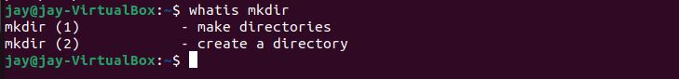

**Program 4: Implement Directory oriented commands: cd, pwd, mkdir, rmdir, Comparing Files using diff, cmp, comm.**

**Directory-** A directory is a file the sole job of which is to store the file names and the related information. All the files, whether ordinary, special, or directory, are contained in directories.

1. **cd command:** It is a shell built-in command for changing the current working directory.

Syntax: cd<directory>

C:\Users\Dell\Desktop\OS\37.JPG

1. **pwd command-** It is a shell built-in command that prints the current location.

The output shows an absolute directory path.

Syntax: pwd



1. **mkdir command-** The mkdir command creates directories. This command can create multiple directories at once as well as set the permissions for the directories. It is important to note that the user executing this command must have enough permissions to create a directory in the parent directory.

Syntax: mkdir [directory names]

C:\Users\Dell\Desktop\OS\39.JPG

This command has created a directory named new.

1. **rmdir command-** The rmdir(remove directory) command is used to delete an empty directory. This command deletes the directory named new.

Syntax: rmdir [directory name]

C:\Users\Dell\Desktop\OS\40.JPG

**Program 5** :**Write a program to create and execute process using fork( ) and exec( ) system calls.**

**What is fork( ) system call?**

The fork system call is used to create a new processes. The newly created process is the child process. The process which calls fork and creates a new process is the parent process. The child and parent processes are executed concurrently.

But the child and parent processes reside on different memory spaces. These memory spaces have same content and whatever operation is performed by one process will not affect the other process.

When the child processes is created; now both the processes will have the same Program Counter (PC), so both of these processes will point to the same next instruction. The files opened by the parent process will be the same for child process.

**Creation and Execution using fork( ):**

Step 1-Firstly write your program in c. For this we will use the nano text editor in the command-line user interface to write our program. Type the following command in the terminal.

nano <file_name_with_extension>



Step 2- Now press enter and write a c program.To exit the editor press Ctrl+X.

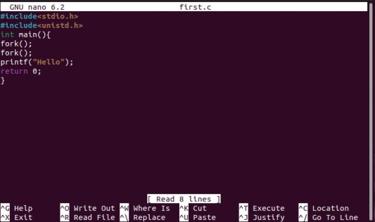

Step 3- Now compile the code using command “gcc <file_name_with_extension>

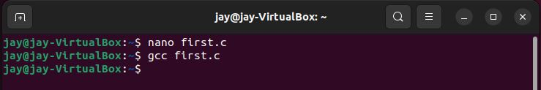

Step 4- Now to get the run the code use command “./a.out”.

C:\Users\Dell\Desktop\OS\53.JPG

Let’s take one more example of fork():

